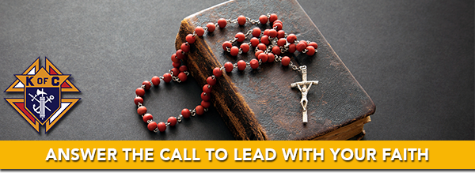

The Knights of Columbus is looking for men like you to join the ranks of the world’s largest Catholic fraternity and grow in your faith. In an ever-changing world, Knights stand together, rooted in God, Family, and Country.
When you join, you’ll have access to a library’s worth of resources to help you better understand, grow in, and defend your Catholic faith.
Explore the richness of our faith through our Catholic Information Service booklets, Columbia Magazine, our monthly publication, and other tools that help you get to know your faith better.
Stay rooted in daily prayer with devotional guides and resources that will help strengthen the faith life of you and your family.
Stand with us and be an unapologetic witness, helping spread the Good News and the Catholic faith, by example, to those we encounter in our daily lives.
Together we can find strength and courage in our faith.

