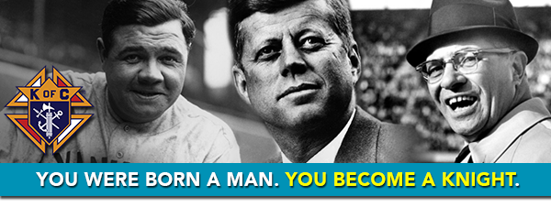

What do Vince Lombardi, Babe Ruth, and President John F. Kennedy all have in common? They were all men of faith. They were all legendary not only for their extraordinary achievements, but also for the many ways they gave of themselves in service to others. They were all Knights of Columbus.

For more than 130 years, Knights have been leaders in their communities. Rooted in faith and supported by a global fraternity of 1.9 million brother Knights, you can be more and do more. When you join us, you’re joining the company of heroic men, and answering a higher call to become what God wants you to be!

Meet other extraordinary Knights who are part of your local council. See what being a Knight can do for you.

